import java.io.*;
import java.util.*;

public class Solution {

public static long stringSimilarity(String s) {

long count = 0;

for (int i = 0; i < s.length(); i++) {

int j = 0;

while (i + j < s.length() &&
s.charAt(j) == s.charAt(i + j)) {
j++;
}

count += j;
}

return count;
}

public static void main(String[] args) throws IOException {

BufferedReader br = new BufferedReader(
new InputStreamReader(System.in)
);

int t = Integer.parseInt(br.readLine().trim());

for (int i = 0; i < t; i++) {

String s = br.readLine().trim();

System.out.println(stringSimilarity(s));
}
}
}

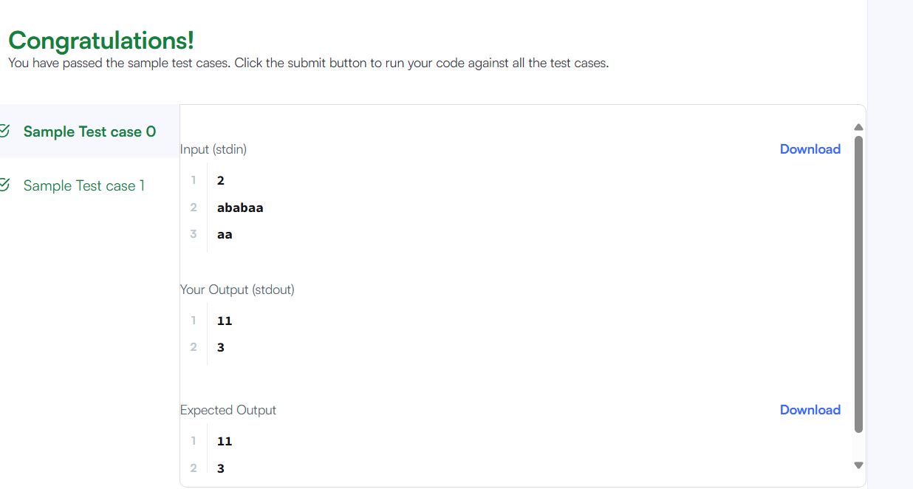

class Solution {
public boolean repeatedSubstringPattern(String s) {

int n = s.length();

for (int len = 1; len <= n / 2; len++) {

if (n % len == 0) {

String part = s.substring(0, len);
StringBuilder result = new StringBuilder();

for (int i = 0; i < n / len; i++) {
result.append(part);
}

if (result.toString().equals(s)) {
return true;
}
}
}

return false;
}
}

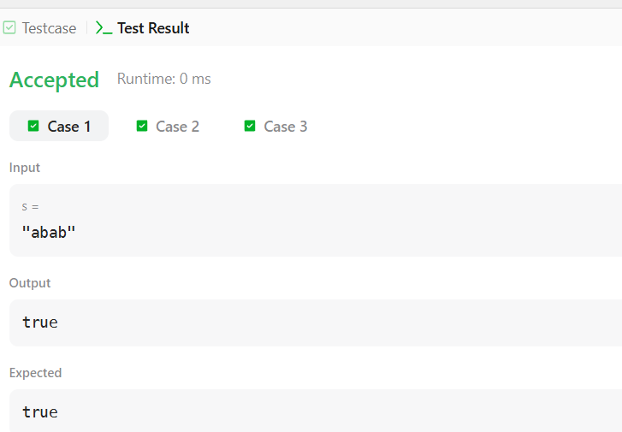
import java.io.*;
import java.util.*;

public class Solution {

public static String twoStrings(String s1, String s2) {

for (char c = 'a'; c <= 'z'; c++) {

if (s1.indexOf(c) != -1 && s2.indexOf(c) != -1) {
return "YES";
}
}

return "NO";
}

public static void main(String[] args) throws IOException {

BufferedReader br = new BufferedReader(
new InputStreamReader(System.in)
);

int q = Integer.parseInt(br.readLine().trim());

for (int i = 0; i < q; i++) {

String s1 = br.readLine().trim();
String s2 = br.readLine().trim();

System.out.println(twoStrings(s1, s2));
}
}
}

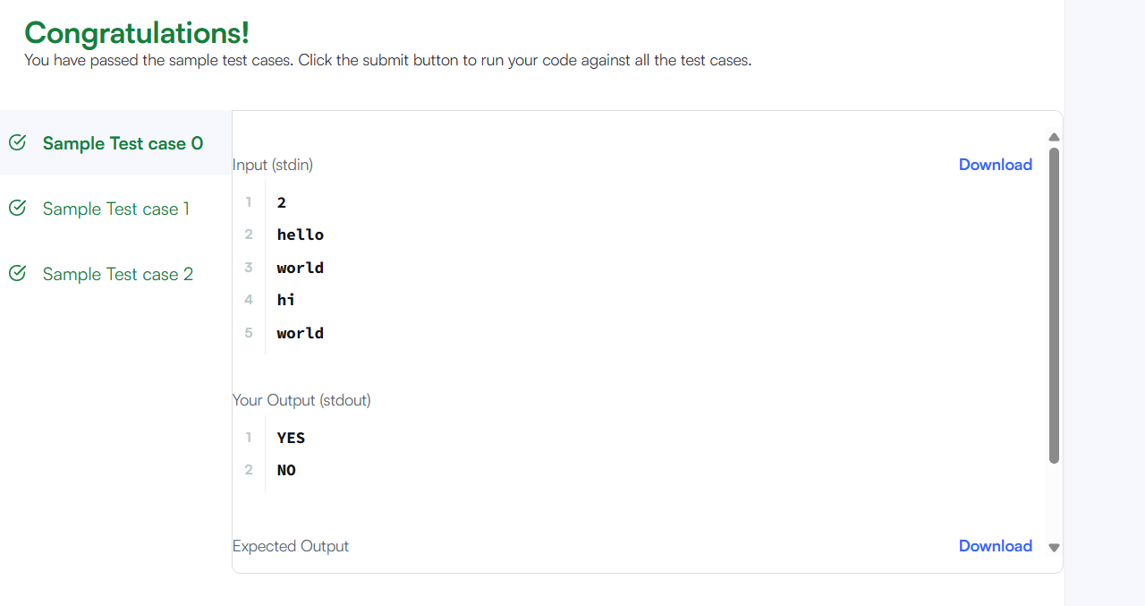

class Solution {
public boolean rotateString(String s, String goal) {

if (s.length() != goal.length()) {
return false;
}

String combined = s + s;

return combined.contains(goal);
}
}

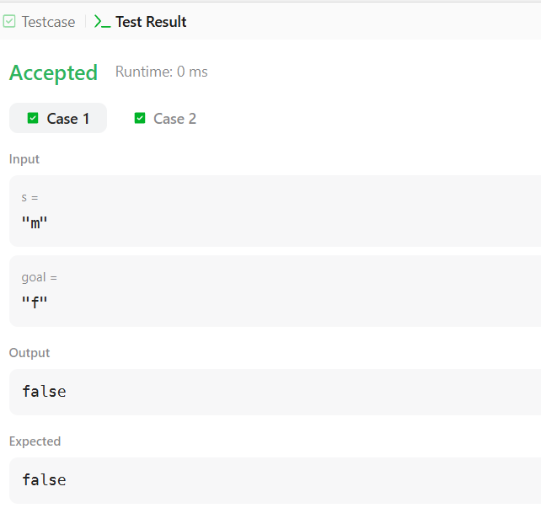

import java.io.*;
import java.util.*;

public class Solution {

public static int marsExploration(String s) {

int count = 0;

for (int i = 0; i < s.length(); i++) {

char expected;

if (i % 3 == 0 || i % 3 == 2) {
expected = 'S';
} else {
expected = 'O';
}

if (s.charAt(i) != expected) {
count++;
}
}

return count;
}

public static void main(String[] args) throws IOException {

BufferedReader br = new BufferedReader(
new InputStreamReader(System.in)
);

String s = br.readLine().trim();

System.out.println(marsExploration(s));
}
}

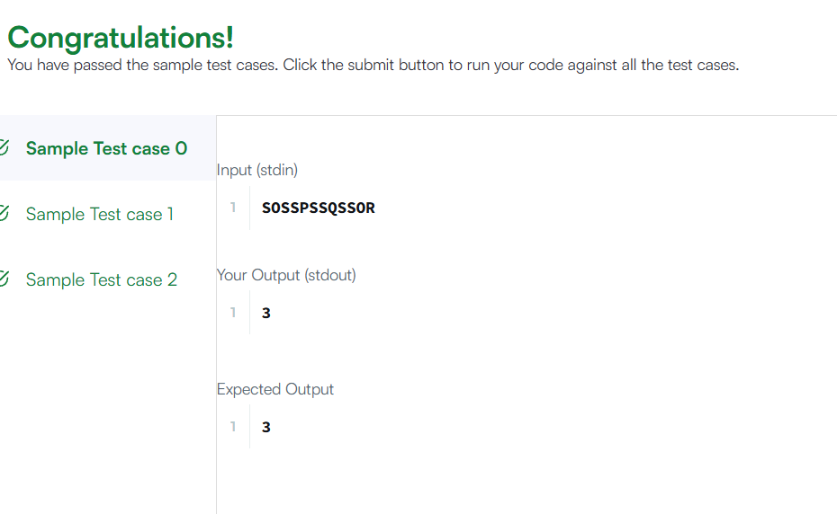

import java.util.*;

class Solution {
public List<Integer> findAnagrams(String s, String p) {

List<Integer> result = new ArrayList<>();

if (s.length() < p.length()) {
return result;
}

int[] pCount = new int[26];
int[] sCount = new int[26];

for (int i = 0; i < p.length(); i++) {
pCount[p.charAt(i) - 'a']++;
sCount[s.charAt(i) - 'a']++;
}

for (int i = 0; i <= s.length() - p.length(); i++) {

if (Arrays.equals(pCount, sCount)) {
result.add(i);
}

if (i + p.length() < s.length()) {
sCount[s.charAt(i) - 'a']--;
sCount[s.charAt(i + p.length()) - 'a']++;
}
}

return result;
}
}

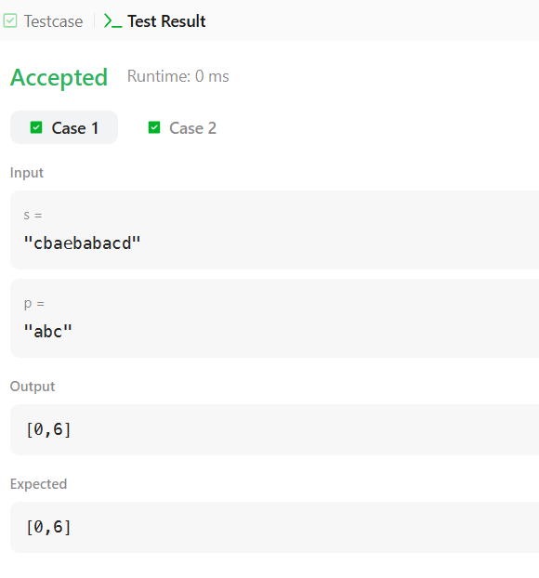

import java.io.*;
import java.util.*;

public class Solution {

public static int palindromeIndex(String s) {

int left = 0;
int right = s.length() - 1;

while (left < right) {

if (s.charAt(left) != s.charAt(right)) {

if (isPalindrome(s, left + 1, right)) {
return left;
}

if (isPalindrome(s, left, right - 1)) {
return right;
}

return -1;
}

left++;
right--;
}

return -1;
}

public static boolean isPalindrome(String s, int left, int right) {

while (left < right) {

if (s.charAt(left) != s.charAt(right)) {
return false;
}

left++;
right--;
}

return true;
}

public static void main(String[] args) throws IOException {

BufferedReader br = new BufferedReader(
new InputStreamReader(System.in)
);

int q = Integer.parseInt(br.readLine().trim());

for (int i = 0; i < q; i++) {

String s = br.readLine().trim();

System.out.println(palindromeIndex(s));
}
}
}

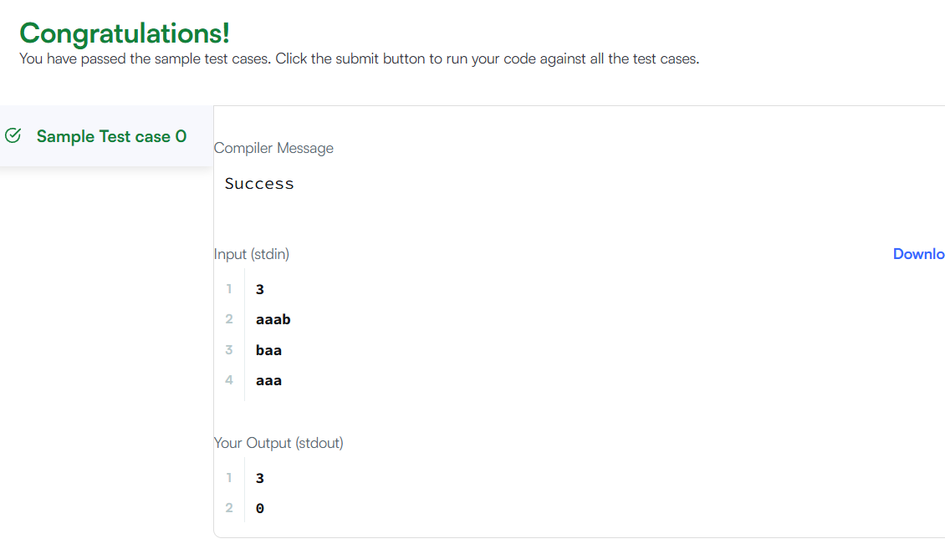

class Solution {
public int strStr(String haystack, String needle) {

for (int i = 0; i <= haystack.length() - needle.length(); i++) {

if (haystack.substring(i, i + needle.length()).equals(needle)) {
return i;
}
}

return -1;
}
}
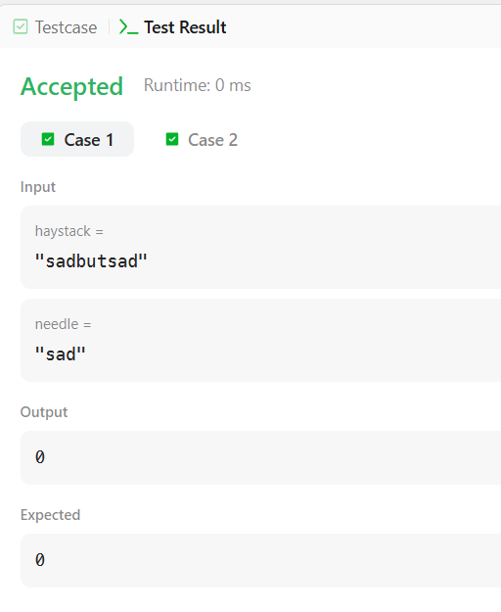

class Solution {
public String longestPalindrome(String s) {

if (s.length() < 2) {
return s;
}

String longest = "";

for (int i = 0; i < s.length(); i++) {

String odd = expand(s, i, i);
String even = expand(s, i, i + 1);

if (odd.length() > longest.length()) {
longest = odd;
}

if (even.length() > longest.length()) {
longest = even;
}
}

return longest;
}

public String expand(String s, int left, int right) {

while (left >= 0 && right < s.length()
&& s.charAt(left) == s.charAt(right)) {

left--;
right++;
}

return s.substring(left + 1, right);
}
}

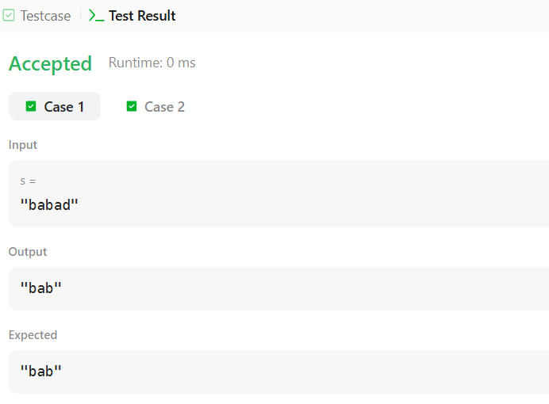

import java.io.*;
import java.util.*;

public class Solution {

public static int getMaxPalindrome(String s) {

int n = s.length();
int max = 1;

for (int center = 0; center < 2 * n; center++) {

int left = center / 2;
int right = left + (center % 2);

int length = expand(s, left, right);

max = Math.max(max, length);
}

return max;
}

public static int expand(String s, int left, int right) {

int n = s.length();
int count = 0;

while (count < n) {

int l = (left - count + n) % n;
int r = (right + count) % n;

if (s.charAt(l) != s.charAt(r)) {
break;
}

count++;
}

if (left == right) {
return 2 * count - 1;
}

return 2 * count;
}

public static void main(String[] args) throws IOException {

BufferedReader br = new BufferedReader(
new InputStreamReader(System.in)
);

String s = br.readLine().trim();

int n = s.length();

for (int start = 0; start < n; start++) {

String rotated = s.substring(start) + s.substring(0, start);

System.out.println(getMaxPalindrome(rotated));
}
}
}

